**EXP_4: Design an application to demonstrate fragments in Android.**

**Project Structure:**

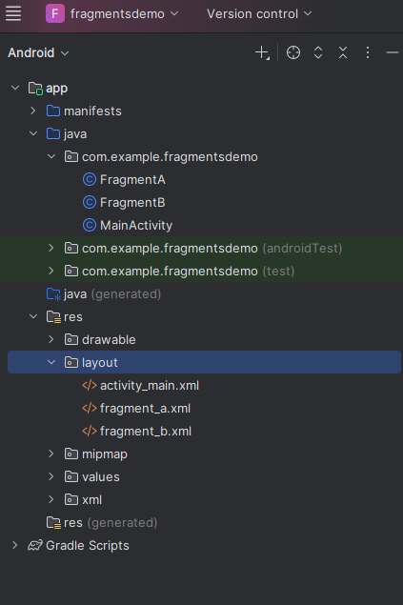

**MainActivity.java**

package com.example.fragmentsdemo;

import androidx.appcompat.app.AppCompatActivity;

import android.os.Bundle;

public class MainActivity extends AppCompatActivity {

@Override

protected void onCreate(Bundle savedInstanceState) {

super.onCreate(savedInstanceState);

setContentView(R.layout.activity_main);

// Load Fragment A initially

if (savedInstanceState == null) {

getSupportFragmentManager().beginTransaction()

.add(R.id.fragment_container, new FragmentA())

.commit();

}

}

}

**FragmentA.java**

package com.example.fragmentsdemo;

import android.os.Bundle;

import androidx.fragment.app.Fragment;

import androidx.fragment.app.FragmentTransaction;

import android.view.LayoutInflater;

import android.view.View;

import android.view.ViewGroup;

import android.widget.Button;

public class FragmentA extends Fragment {

@Override

public View onCreateView(LayoutInflater inflater, ViewGroup container,

Bundle savedInstanceState) {

View view = inflater.inflate(R.layout.fragment_a, container, false);

Button btn = view.findViewById(R.id.btnLoadB);

btn.setOnClickListener(v -> {

FragmentB fragmentB = new FragmentB();

FragmentTransaction transaction = getFragmentManager().beginTransaction();

transaction.replace(R.id.fragment_container, fragmentB);

transaction.addToBackStack(null);

transaction.commit();

});

return view;

}

}

**FragmentB.java**

package com.example.fragmentsdemo;

import android.os.Bundle;

import androidx.fragment.app.Fragment;

import android.view.LayoutInflater;

import android.view.View;

import android.view.ViewGroup;

import android.widget.TextView;

public class FragmentB extends Fragment {

@Override

public View onCreateView(LayoutInflater inflater, ViewGroup container,

Bundle savedInstanceState) {

View view = inflater.inflate(R.layout.fragment_b, container, false);

TextView tv = view.findViewById(R.id.tvMessage);

tv.setText("Welcome to Fragment B!");

return view;

}

}

**activity_main.xml**

<?xml version="1.0" encoding="utf-8"?>

<FrameLayout xmlns:android="http://schemas.android.com/apk/res/android"

android:id="@+id/fragment_container"

android:layout_width="match_parent"

android:layout_height="match_parent" />

**fragment_a.xml**

<?xml version="1.0" encoding="utf-8"?>

<LinearLayout xmlns:android="http://schemas.android.com/apk/res/android"

android:orientation="vertical"

android:gravity="center"

android:layout_width="match_parent"

android:layout_height="match_parent">

<Button

android:id="@+id/btnLoadB"

android:layout_width="wrap_content"

android:layout_height="wrap_content"

android:text="Go to Fragment B" />

</LinearLayout>

**fragment_b.xml**

<?xml version="1.0" encoding="utf-8"?>

<FrameLayout xmlns:android="http://schemas.android.com/apk/res/android"

android:layout_width="match_parent"

android:layout_height="match_parent"

android:gravity="center">

<TextView

android:id="@+id/tvMessage"

android:layout_width="wrap_content"

android:layout_height="wrap_content"

android:textSize="20sp"

android:textColor="#000000"/>

</FrameLayout>

